8.0.1.1 Sequence diagram login
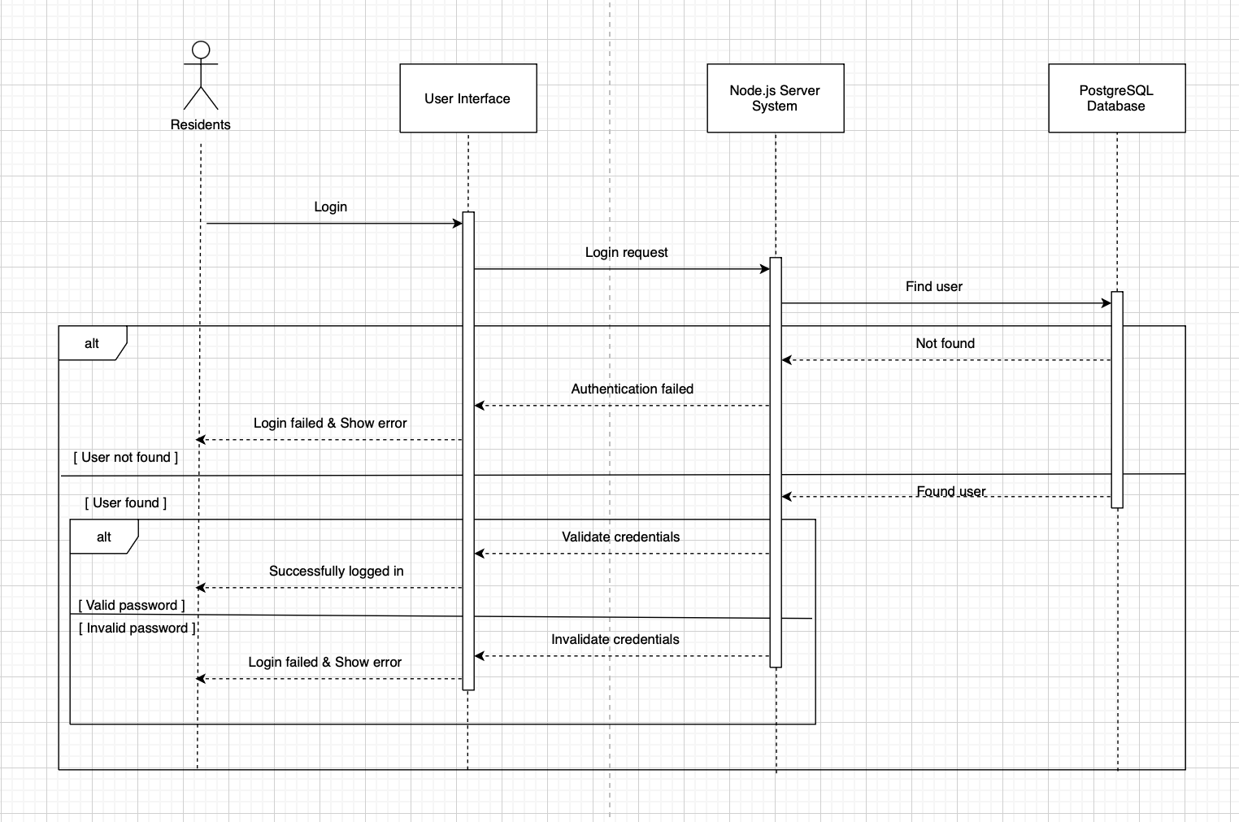
8.0.1.2 Sequence diagram submitting form request
